**Dr. D. Y. Patil Institute of Technology,**

**Pimpri, Pune-411018**

Department of Computer Engineering

# 

**A MINI PROJECT REPORT ON**

**Student Management System**

##### SUBMITTED BY

**Miss. Shreya Prashant Mahajan** Exam Seat No - **T1902404345**



## DEPARTMENT OF COMPUTER ENGINEERING

**Dr. D. Y. PATIL INSTITUTE OF TECHNOLOGY,**

**PIMPRI, PUNE**

## SAVITRIBAI PHULE PUNE UNIVERSITY

## 2024 -2025



**CERTIFICATE**

This is to certify that the project report entitled

**“Studen Management System”**

Submitted by

**Miss. Shreya Prashant Mahajan** Exam No **:** **T1902404345**

is a bonafide student of this institute and the work has been carried out by him under the supervision of **Prof. Pranal Kakde** and it is approved for the partial fulfillment of the requirement of Savitribai Phule Pune University, for the award of the degree of Computer Engineering.

**(Prof. Pranal Kakde)** **(Dr. Vinod Kimbahune)**

Guide Head,

Department of Computer Engineering Department of Computer Engineering

**(Dr. Lalit Kumar Wadhwa)**

Principal,

**Dr. D. Y. PATIL INSTITUTE OF TECHNOLOGY,**

**PIMPRI, PUNE**

Place : Pune

Date :14/10/2024

DECLARATION OF THE STUDENT

I declare that this written submission represents my ideas in my own words and where others’ ideas or words have been included, I have adequately cited and referenced the original sources.

I also declare that I have adhered to all principles of academic honesty and integrity and have not misrepresented or fabricated or falsified any idea / data / fact / source in my submission.

I understand that any violation of the above will be cause for disciplinary action by the Institute and can also evoke penal action from the sources which have thus not been properly cited or from whom proper permission has not been taken when needed.

### **Miss. Shreya Prashant Mahajan**

**T1902404345** Date:- 14/10/2024

**ABSTRACT**

The Student Management System (SMS) is an advanced software solution designed to efficiently manage and maintain student data within schools, colleges, and universities. It automates the process of handling various student-related information, including personal details, academic records, course enrolment, and college details. By digitizing these processes, the system reduces the time, effort, and cost traditionally involved in manual data handling.

The SMS serves as a central hub for the administration to track and update student information in real-time. This system also streamlines communication by providing easy access to updated records and information for both students and faculty. The adoption of Student Information Systems (SIS) has significantly improved the performance and efficiency of educational institutions by reducing administrative workload, enabling better data organization, and fostering transparency.

In recent years, the widespread use of SMS has revolutionized the education industry, transforming how student records are managed and how information is shared. This tool ensures the seamless flow of academic processes, making it an essential part of modern educational institutions.

**TABLE OF CONTENTS**

# 

|  |  |  |  |  |
| --- | --- | --- | --- | --- |
| **Sr. No.** | | | **Title of Chapter** | **Page No.** |
| **01** | | | **Introduction** | 6 |
| **02** | | | Software Requirements Specification | 6 - 9 |
| **03** | | | ER Diagram | 10 |
| **04** | | | Results | 11 |
|  | | 4.1 | Outcomes | 11 - 15 |
|  | | 4.2 | Screen Shots | 11 - 15 |
| **05** | | | Conclusions | 16 |
|  | 5.1 | | References | 17 |

1. **Introduction**

A Student Management System can handle all the details about a student.

The details include College details, Course details, Students personal details, Academic details etc. If we do these activities manually it is very time consuming and costly so this system can help to manage all data of student.

Schools and Universities are the foundation of knowledge and an educational body on which students rely upon. Therefore, they need to maintain a proper database of its students to keep all the updated records and easily share information with students.

Most schools and Universities count on an advanced software tool knows as 'Student Information System (SIS)' to keep all their student records.

Over the recent years, the performance and efficiency of the education industry have been enhanced by using the Student Management System. This tool has productively taken over the workload of the admin department with its well-organized, easy, and reliable online school management software.

**•Objective**

The primary objective of the Student Management System (SMS) is to provide an efficient, user-friendly platform for managing and maintaining student-related data within educational institutions. Key objectives include:

1. **Automate Administrative Tasks**: Streamline and automate routine tasks such as student registration, course enrolment, academic record management, and fee processing to reduce manual effort and errors.
2. **Centralized Data Management**: Create a centralized database that holds comprehensive information about students, including personal details, academic performance, attendance, and course details, making it easily accessible to authorized users.
3. **Improve Communication**: Facilitate better communication between students, faculty, and administrative staff by providing a platform to share information and updates quickly and efficiently.
4. **Enhance Data Security**: Ensure the security and privacy of student data by providing controlled access to sensitive information, reducing the risk of unauthorized access and data breaches.
5. **Increase Efficiency**: Optimize the overall functioning of academic and administrative processes, resulting in increased productivity, faster decision-making, and a reduction in administrative costs.

2. **Software Requirements Specification /Methodology**

**Software Requirements:**

• Operating System: Windows 11

• Software: jdk 1.6, notepad, MS office, MS access.

**Hardware Requirements:**

• Processor: AMD A9-9420 RADEON R5, 5 COMPUTER CORES 2C+3G 3.00GHz

• RAM : 4 GB

**IMPLEMENTATION AND RESULT**

Following are the screens of the Student Management System where you can see all the features of this system in use and you can also see the GUI of the system:

1. **Login frame** – This is the login frame of this system where Student have to enter the required credentials to have access for the main dashboard. 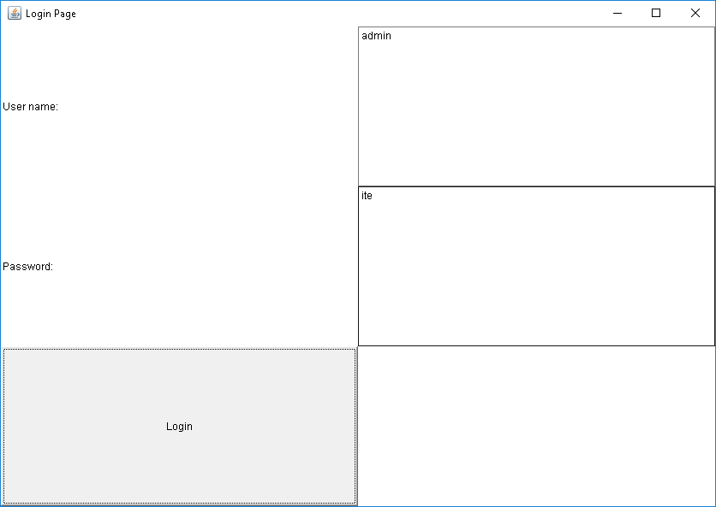

Fig. 1

1. **Main Dashboard** – After login in, user is directed to the main dashboard of this system where user can perform various operations like adding an Students, deleting an Students

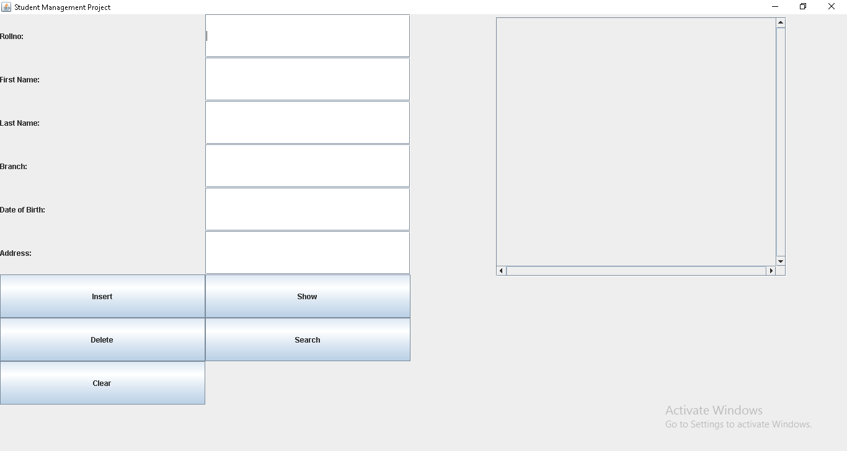

Fig. 2

1. **Add student** – Here user have to enter all the required credentials to add a new employee to the system.

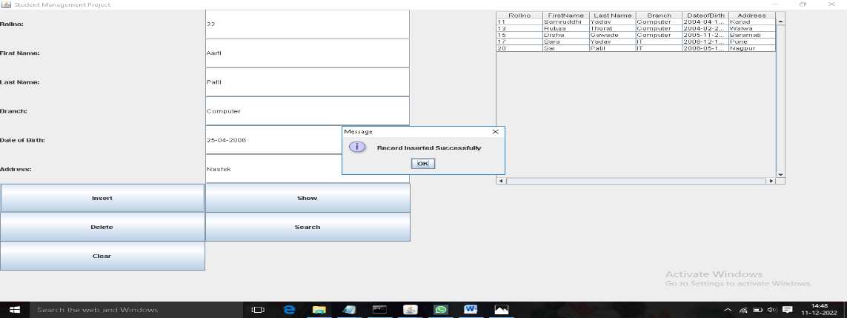

Fig. 3

1. **Remove student** – User has to enter the student id in order to delete his information from the system.

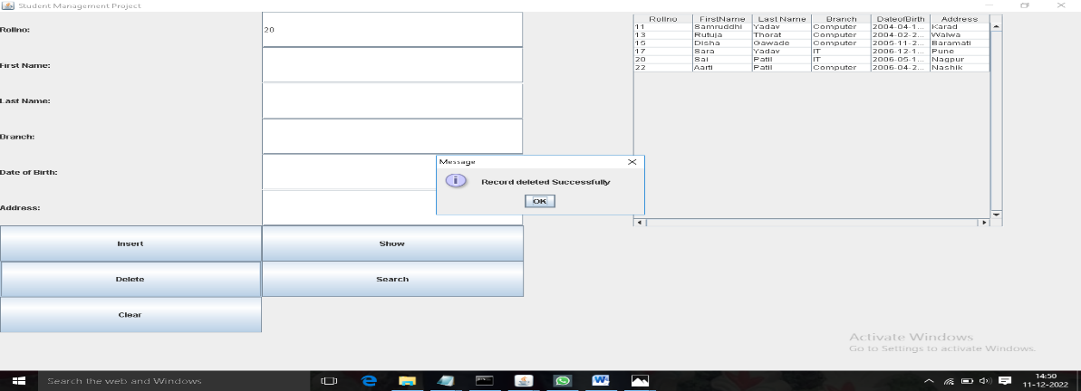

Fig. 4

1. **View and update student** – In order to view and update employee information, the user have to enter student ID.

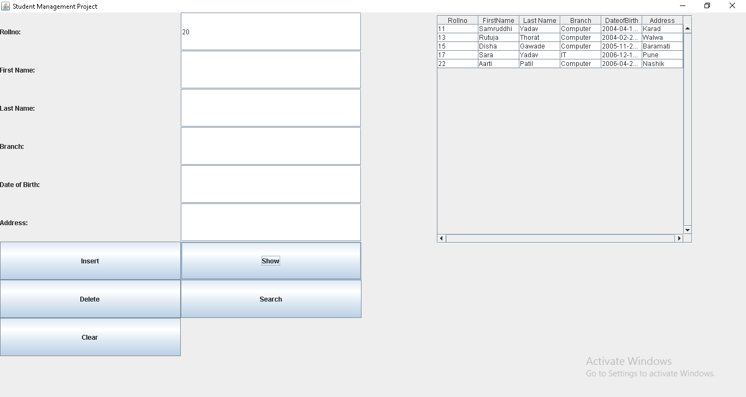

1. **ER DIAGRAM:-**

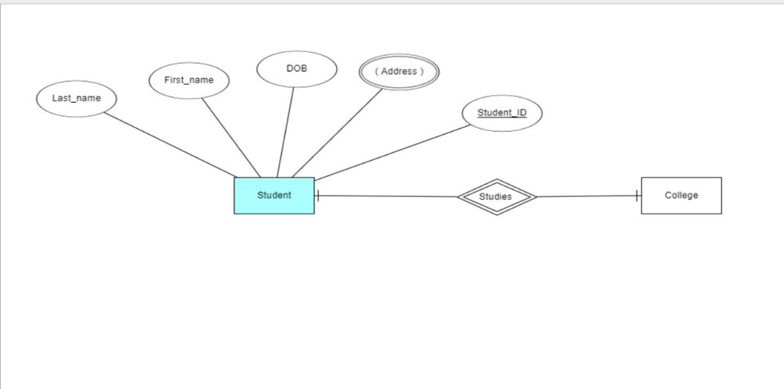

1. **RESULTS:-**

**4.1 OUTCOMES:**



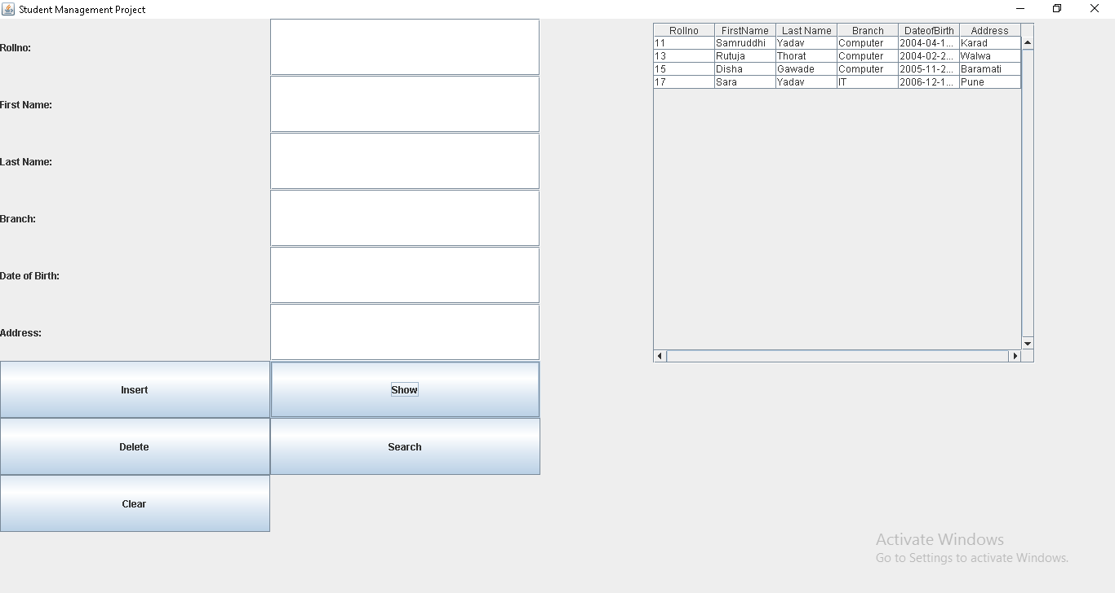

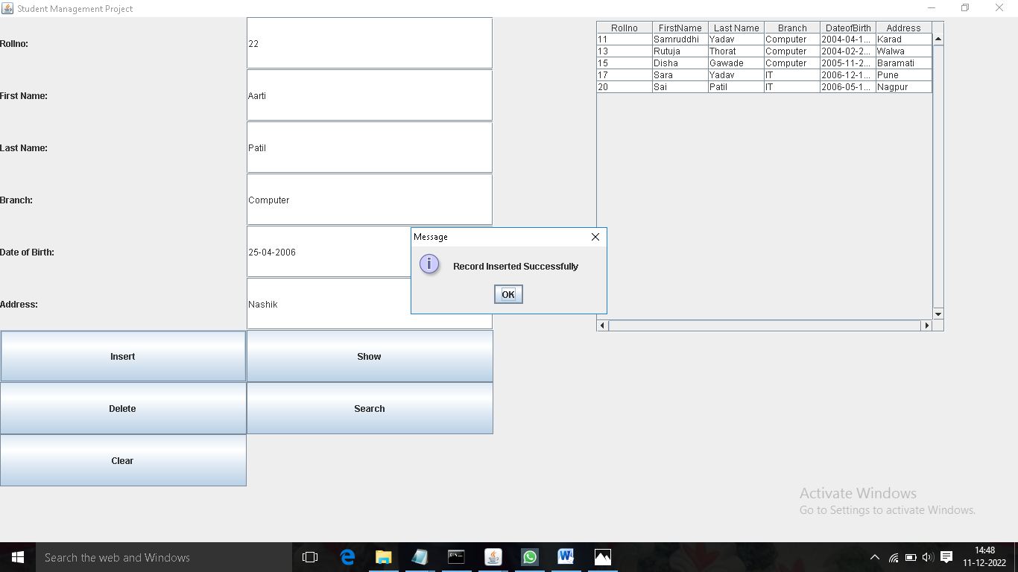

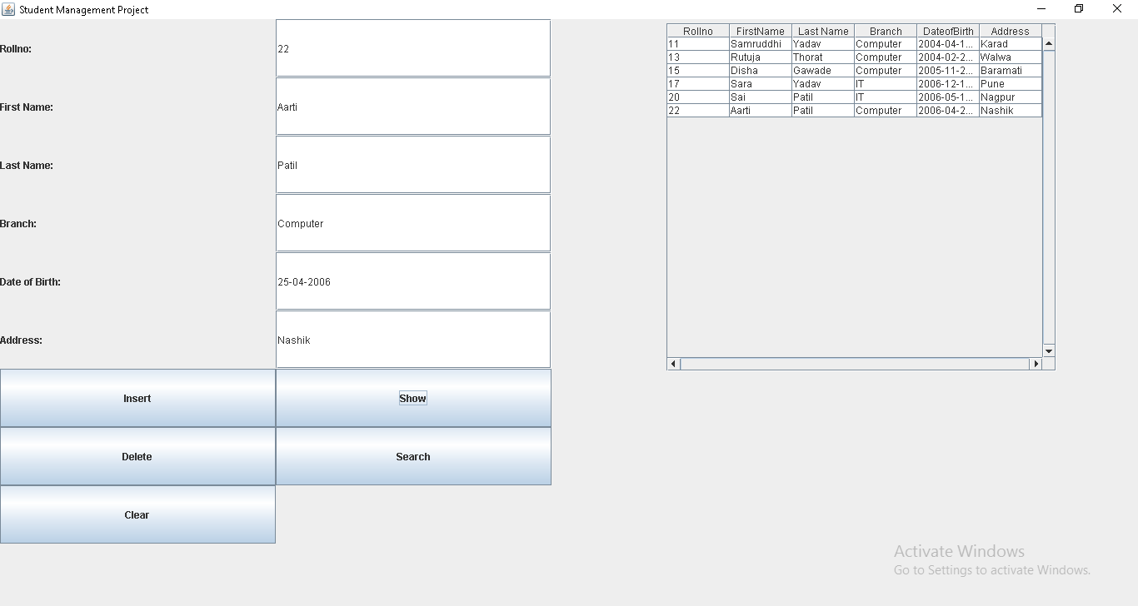

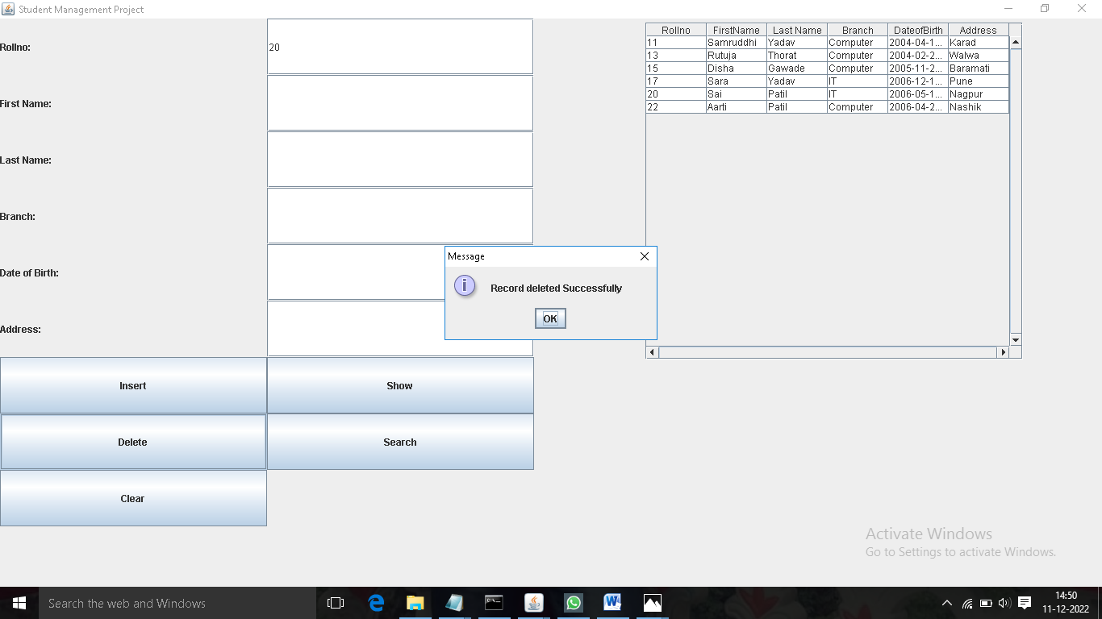



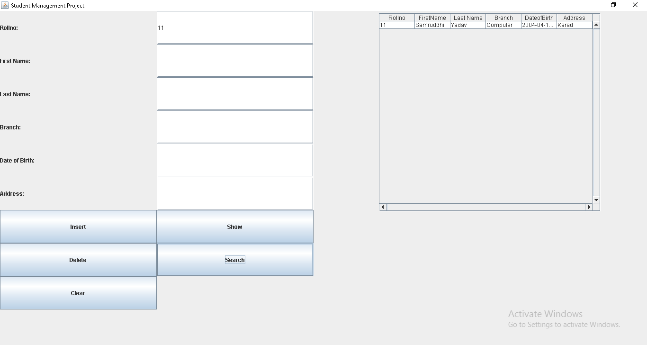

1. **Conclusion**

* Student management System helpful to perform paperless work and manage all data of students.
* It provides easy, accurate, unambiguous and faster data access.
* It provides a user friendly, error free environment to manage large amount of data.
* The application provides appropriate information to users according to the chosen service.
* Student Management System can be used by educational institutions to maintain their student records easily.

**Future Scope**

The Student Management System (SMS) has significant potential for growth and improvement to further enhance the educational experience for institutions, administrators, teachers, and students. Some areas of future scope include:

1. **AI and Machine Learning Integration**: The integration of AI and machine learning could enable predictive analytics to monitor student performance, identify at-risk students, and recommend personalized learning paths and interventions based on academic history and behavior patterns.
2. **Mobile Application Development**: Expanding the system into mobile applications for students, teachers, and administrators would improve accessibility and convenience, allowing stakeholders to access and update information from anywhere at any time.
3. **Cloud-based Solutions**: Implementing cloud-based SMS will make it easier for institutions to scale their operations, handle larger data volumes, and ensure data availability and backup without the need for complex in-house IT infrastructure.
4. **Integration with Learning Management Systems (LMS)**: Seamless integration with Learning Management Systems can allow real-time synchronization of student academic records, making it easier to track coursework, assessments, and grades across multiple platforms.

**References:**

Reference books and websites used during the entire project……..

**Reference book** **Author**

1. Advance Java Programming. -Ravi Majithia
2. Advance Java Programming. -Dr.Meenakshi A. Thalor

**Web Reference -**

1. <https://www.javatpoint.com/java-jdbc>
2. <https://www.cwipedia.in/2020/12/22517-notes-pdf-ajp-msbte.html>